Confusion matrix
The confusion matrix is used to describe the performance of a classification model on a set of test data for which true values are known.

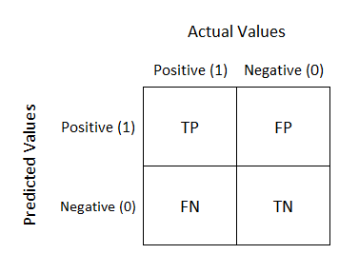
confusion matrix
From the confusion matrix the following information can be extracted :
- True positive(TP).: This shows that a model correctly predicted Positive cases as Positive. eg an illness is diagnosed as present and truly is present.
- False positive(FP): This shows that a model incorrectly predicted Negative cases as Positive.eg an illness is diagnosed as present and but is absent. (Type I error)
- False Negative:(FN) This shows that an incorrectly model predicted Positive cases as Negative.eg an illness is diagnosed as absent and but is present. (Type II error)
- True Negative(TN): This shows that a model correctly predicted Negative cases as Positive. eg an illness is diagnosed as absent and truly is absent.

Precision.

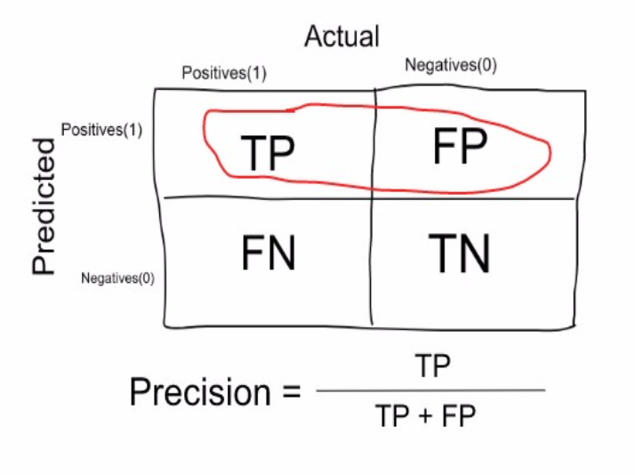

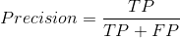

Recall.

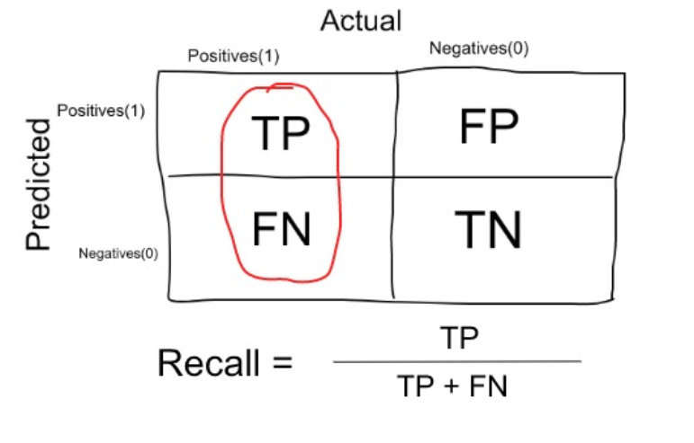
Recall score(Sensitivity): This is the true positive rate that is if it predicts positive then how often does this take place?

Recall
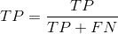
The F1 score is calculated based on the precision and recall of each class. It is the weighted average of the Precision and the recall scores. The F1 score reaches its perfect value at one and worst at 0.It is a very good way to show that a classifies has a good recall and precision values.

F1 Score
We can calculate it using this formula:

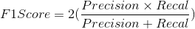

Accuracy
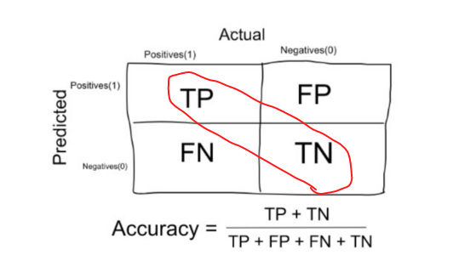

ROC_AUC_Curve

TPR(Recall)
True Positive Rate = True Positives / (True Positives + False Negatives)

TNR
True Negative Rate = True Negative / (True Negative + False Positive)

FNR(Specificity)
False Negative Rate = 1- TNR

Thresholds
[classes, max_val, min_val]

Exapmle
[0. 0.08823529 1. ](from 0 tpr to 1)
[0. 0.875 1. ]( from 0 fnr to 1)

[2 1 0] (2 classes t0 1 from 0)

